1. **INTRODUCTION**

As the number of vehicles increases, road accidents are on the rise every day. According to the World Health Organization (WHO) survey, 1.4 million people have died, and 50 million people have been injured worldwide every year. The key cause of death is the unavailability of response time in the rescue operation. This project deals with the concept which can detect accidents or damage without any human assistance. Detection of accidents is done automatically by using a simple setup that will be embedded in the vehicle. Once the vehicle met with an accident the accident detection setup will sense the buzzer and immediately sends the location to the user contact numbers. An IoT kit is developed that detects the accident and sends the live location to all the contacts of the user. This will help us to minimize delays in a rescue operation that could save many lives.

Over 10 million people are injured yearly worldwide in road accidents. Lack of attention by the driver is identified as the cause for 91% of driver-related accidents. An extra second of warning time can prevent about 90% of rear-end collisions. This places Collision Detection System (CDS) systems high on the list of solutions that can contribute significantly to the reduction of the number and the severity of driving accidents. A range sensor mounted on the vehicle could provide a practical solution to this problem. Most of the traditional collision avoidance systems today are based on Radar sensors, which have a narrow field of view and poor lateral resolution and provide limited information about the object and distance.

In urban areas accidents are most common phenomena where many of such accidents can be taken care easily but some accidents occur during night time when the visibility is quite low, during such cases it will be difficult to identify the accident spot with the help of phone calls made by the citizens.

Now a day’s major part of the accident due to uneven interruption of vehicles and irregular driving by the owner. There are lot of study about predicting a detecting the vehicle accident but there is no pre intimation to the drivers about the accident. In this project we propose to overcome the accident. Thus we provide a solution based on IOT accident prediction and detection using supervise machine learning algorithm this system will collect the necessary information or data from the sensor and through machine learning algorithm the accident will be predicted using data sets. The essential data or values are collected using MEMS and vibration sensor, through the KNN algorithm sensor value are processed and when it reaches the threshold value which exceed the predefined value an notification is passed to the user’s predefine contacts along with live location. Some people can be saved at that time, but because of lack of information, time and place it may not be possible. Our project will provide an optimum solution to that draw back. Dangerous driving can be detected with an accelerometer. According to this project when a vehicle met with an irregular driving with the using of IoT.

A collision detection system is a safety system designed to warn, alert, or assist drivers to avoid imminent collisions and reduce the risk of accidents.

The system will be IoT based and will have five components i.e Arduino Board, GSM Module 800A, buzzer, accelerometer, GPS location tracker. The main objective of this project is to reduce the time factor in case of accidents. There are many cases where an accident occurs during the night and the person met with the accident is unconscious then it would take hours for someone to find out and inform the authorities about it. So, saving such precious time will indeed save lives. Once the vehicle met with an accident the accident detection setup will sense the buzzer and immediately sends the location to the user contact numbers. An IoT kit is developed that detects the accident and sends the live location to all the contacts of the user.

**SCOPE**

The aim is to rescue people from the collision and also to reduce death rate that caused because of collision. This project will detect the accidental spots and the user default message (saying that the collision has taken place and the person needs a rescue) to all the contact list along with the live location.

Here, we make use of sim network rather than internet.

**PROJECT MANAGEMENT**

Management of any project can be briefly disintegrated into several phases. Our project has been decomposed into the following phases:

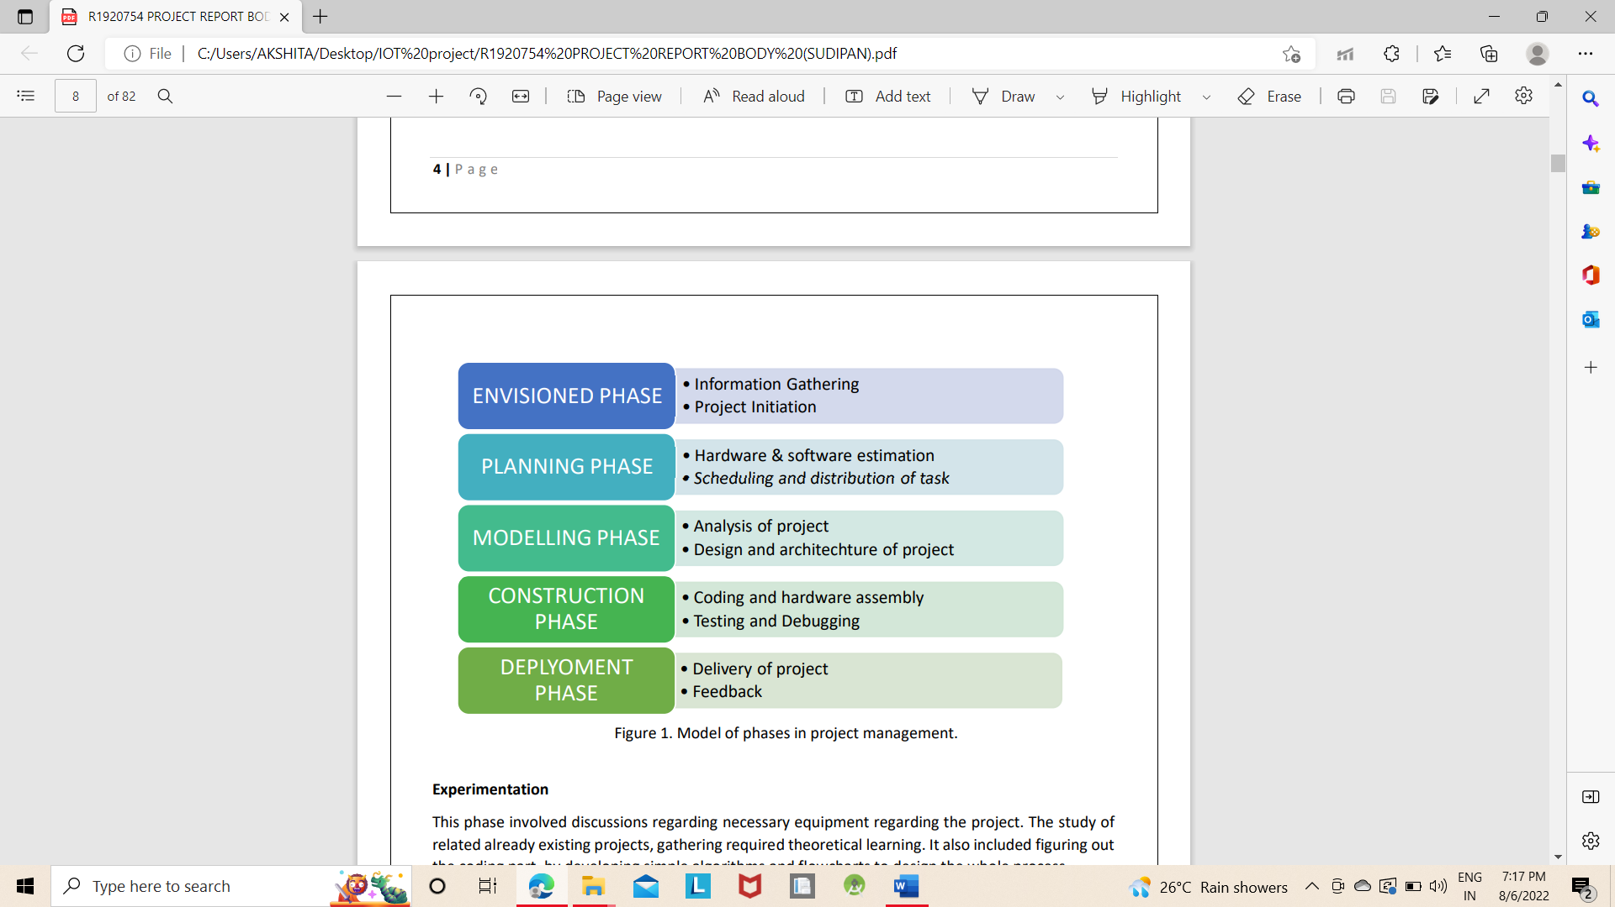

**Experimentation**

This phase involved discussions regarding necessary equipment regarding the project. The study of related already existing projects, gathering required theoretical learning. It also included figuring out the coding part, by developing simple algorithms and flowcharts to design the whole process.

**Design**

This phase was, designing layout of the application, and the necessary features to be included. This involved the complete hardware assembly and installing the code to Node MCU. The power strip was designed to connect the home appliances that can be controlled via GPIO pins.

**Development and testing**

This phase had the development of the application. The android device was connected to the Node MCU via wireless network (Wi-Fi) and the whole prototype was tested for identification and removal of bugs.

**Real world testing**

The prototype was ready to be tested into the real world and integrated with various real time electrical appliances.

**OVERVIEW AND BENEFITS**

The benefits of an established wireless remote switching system of home appliances include:

• Information Gathering

• Project Initiation ENVISIONED PHASE

• Hardware & software estimation

• Scheduling and distribution of task PLANNING PHASE

• Analysis of project MODELLING PHASE

• Design and architecture of project

• Coding and hardware assembly

• Testing and Debugging CONSTRUCTION PHASE

• Delivery of project

• Feedback DEPLYOMENT PHASE.

No legal issues Obtaining access to or traversing properties with hard lines is extremely difficult. Reduced wiring issues Considering the increase in price of copper, thus increases the possibility of the wire to be stolen. The use of a wireless remote system to control home appliances means no wire for thieves to steal. Extended range as the system establishes control over Wi-Fi, it was a generally considered descent range. That is 150 feet indoors. Outdoors it can be extended to 300 feet, but since the application is of a HAS, an indoor range is considered. Security As the connection of the control of the HAS is established over a secure network the system ensures security to the maximum extent. Integrable and extensive nature. The prototype designed can be integrated to a larger scale. Also, it has an extensive nature being able to add or remove the appliances under control according to application.

1. **LITERATURE SURVEY**

**IOT BASED VEHICLE COLLISION DETECTION & RESCUE INFORMATION SYSTEM (IVADR)**

In this paper IoT based vehicle collision detection and rescue in order system is developed. This is old to discover the vehicle mistake and send out the place in rank of the calamity residence to vehicle owner, nearby sanatorium and police force locate by the use of a network service. The announcement between the web server and hardware trick is customary by way of GSM/GPRS shield, and the place is traced by means of the GPS shield. In this thesis manufactured a novel factor based vehicle tracking algorithm, accordingly make something stand out and footprint a hardly any poignant articles. The hardware ruse by means of sensors and mass in the mesh server, and fire notification to diverse users by means of network application. Catalog head waiter and API and fulfils ever the chuck to be an IoT based framework.

**TRAFFIC COLLISION DETECTION BY USING IoT(TCDI)**

In this manuscript system will assemble needed in sequence from fellow citizen vehicles and handle that in rank by means of device education tools to find promising accidents. Apparatus education algorithms possess given away accomplishment on distinguishing abnormal behaviours than typical behaviours. That passage manners be capable of be analysed by means of vehicle positions and speeds and abnormal behaviour on the road. Clustering algorithms preserve be old to assembly vehicles according to their haste and locality in fastidious path segment. The side road may possibly be measured potential peril for the drivers who are seal off to confrontation area.

**IOT BASED COLLISION IDENTIFICATION AND ALERTING SYSTEM (IBAL)**

In this daily system will employment on if a vehicle meets with an accident, the accelerometer and ultrasonic sensor discover the hint at and sent it to the Arduino. As the mishap occurs, the accelerometer senses the quickening and sends an indication to the Arduino. So, therefore it will fire an alert implication to the predefined number. Followed by the LCD television will exhibit a memorandum as memorandum sent. This programmed vehicle smash identification is the system which tin perceive the accidents in a lesser amount of time and sends the in order to the primary support focal point with user-friendly and reliable. This anticipated style is greatly beneficial to the automotive industry.

**REALTIME LOCATION PREDICTION WITH TAXI-GPS DATA STREAMS (RTLP)**

In this dissertation system anticipated to predict the destination location. This study four incremental scholarship methods by means of a Damped space mock-up namely, Multivariate compound regression, Spherical-spherical regression, Randomized circular K-NN falling off and an group of these methods for their effectiveness in solving the destination prediction problem. The site hitch is as well painstaking and the aforementioned methods are examined for their suitability via truly humanity datasets. MMR is the superlative drama sense in conditions of prediction accurateness what time the teaching records sizes are large. While the guidance information sizes are minor to moderate it follows that mutually the RF and SVR methods are reliable choices making an allowance for equally prediction exactness and tote up computation time.

**AN IOT BASED ACCIDENT PREVENTION & TRACKING SYSTEM FOR NIGHT DRIVERS (IBAD&TS)**

In this document provides taste Blink Monitoring System (EBM) that alerts the subject during dignity of drowsiness. An embedded system based on psychological official of Subject by monitoring look at arrangements and beginning appointments are beneficial in counsel drivers during first be asleep sequence point of drowsiness. The physiological have a siesta kingdom psychiatry of subject container be single-minded by monitoring subject’s eye blink evaluate via an IR sensor and travel group by means of an accelerometer. An ordinary look at blink fee has no provoke on the output of the system. Interfacing of effortless sensors to a number of micro-controller platforms enables the slacken off of flexible the embedded system at an experienced levels of computerization.

**AN IOT BASED ACCIDENT PRVENTION AND TRACKING SYSTEM (IBAP)**

This article provides the command pressure group that alerts the subject during the kingdom of drowsiness. An embedded system based on psychological formal of the subject by monitoring be in first place travels is of use in word drivers during original catnap round segment of drowsiness. The physiological snooze glory psychotherapy of the subject container be strong-minded by monitoring be foremost advance via an accelerometer. An Internet of belongings enabled sensors are old to transmit the complete numbers composed by sensors over a smart grid meet people for quick on the uptake answer side to assume events under tragedy conditions. The control faction of the driver is detected by the MEMS sensor and it sends a memo to the registered mobile digit proverb lethargy detected.

**IOT BASED ACCIDENT PREVENTION AND MONITORING SYSTEM IN RAILWAYS (IBAPMSR)**

In this paper, it depict the array of sensing based sensor technologies has extended rapidly, where sensor procedure enclose be converted into cheaper. It leads to a better opening out in term monitoring of systems, structures, vehicles, and machinery by sensors devices. Imperative vital factors in this railway road monitoring system are the now-a-days well ahead technology in networking technologies such as wireless, Wi-Fi communication and mobile announcement hoc networking coupled with the technology to integrate devices. Implementation is based on which the sensor is included. For transfer tracks, closer coach monitoring system are enabled by individual vibratory wireless and circuits sited at apt areas to expansion the stability of the system and evaluate the results.

**3. SYSTEM REQUIREMEMTS**

**HARDWARE REQUIREMENTS:**

* ARDUINO UNO
* BUZZER
* GPS-6M
* ACCELEROMETER
* GSM 800 A

**SOFTWARE REQUIREMENTS:**

* ARDUINO STUDIO
* PROGRAMMING LANGUAGE: C

1. **SYSTEM DESIGN**

System designing is a modelling process. It is a solution, how to approach to create a new system. It can be defined as a transition from user’s view to programmer's or database person's view. The design phase mainly depends on the detailed specification in the feasibility study. The system design phase acts as a bridge between the requirement specification and the implementation phase. From a project management point of view software design is conducted in two steps. Preliminary design is concerned with the transformation of requirements into data and software architecture. Detailed design focuses on refinement to the architectural representation that leads to detailed data structure and algorithmic representation for software.

The major steps in the design phase are input design, output design, and dealing with the coding issue. The very first step is design of input and output screen to the client requirements. Next comes the various issues that should be dealt coding and the code should be such that it should be compatible with the real time environment and should be generic in nature.

System design is a process through which requirements are translated into a representation of software. Initially the representation depicts a holistic view of software. Subsequent refinement leads to a design presentation that is very close to source code. Design is a place where quality fostered in software development. Design provides us with representation of software that can be assessed for quality, this is the only way that can accurately translate the customer requirements into finished software product or system.

**Conceptual Design**

Conceptual Design is the process of acquiring and evaluating, documenting and then validating what the user envisions to be business relation. It identifies the user and business requirements of the application and leads to a business solution as seen by the user.

All applications are built to solve business problems and it is important to pay close attention to principle that the business need drives application development. At any point the design process, the current state of the design should be directly traceable to a business problem and requirements.

To achieve this conceptual design is driven by developing usage scenarios. These scenarios are a direct representation of the user's view of the solution to a specific business problem. A conceptual view places the emphasise on solving a business problem and deriving a solution that corresponds to the needs and requirement of the users. It is based on deriving the behaviour of the solution with a primary emphasizes on the user. Beginning with an emphasis on the activities of the business rather than aspects of software development, underscores the fact that systems exist to serve the business. A strong focus on the user in the beginning of the project will help in maintaining a proper perspective throughput the development lifecycle. The conceptual design results in the first description of what the system does to solve the business problem articulated in the vision /scope document.

**Logical Design**

Logical Design derives business objects and their related services directly from these usage scenarios. The logical view of the solution provides a basis for evaluating different physical options. It also formalizes the solution for the project team.

The idea of the application is that the system first emerges in logical design. Its boundaries and business objects and it contain the system definition. Logical design specifies the interfaces between the system and external entities, such as users and other systems. Within a system there may be a number of sub-systems, and these boundaries are also specified.

**Diagram:**

**4.1 Working model of collision detection**

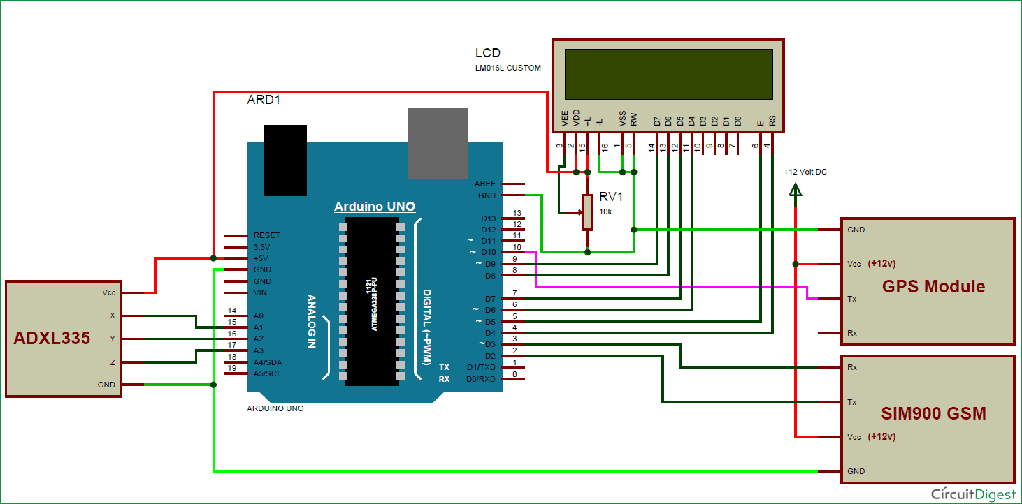

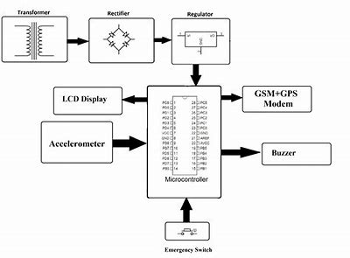

**Fig: Working model of collision detection system**

**4.2 Data Flow Diagram**

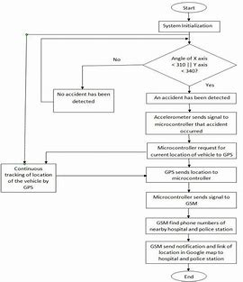

* A data flow diagram shows the logical flow of data through a transaction processing system of an organization.
* They are primarily used in the system development process as a tool for analyzing an existing system.

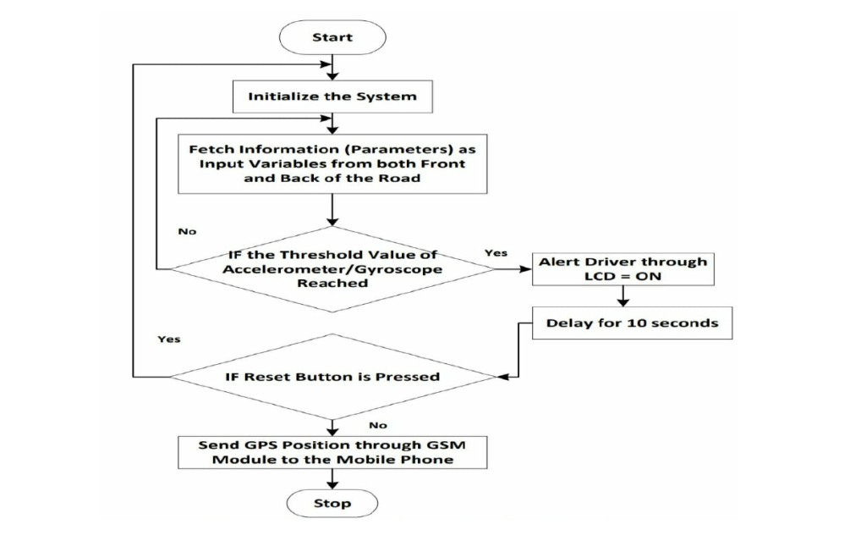**Fig: data flow diagram of collision detection system**

**Data Flow:**

* Data move in specific direction from an origin to a destination in the form of a document.

Image

Image

**Process:**

* Procedure or devices that use or transform data



**Source or Destination of Data:**

* Source or Destination of data, which may be people, organization or other entities, interact with the system but are outside its boundary.



**5.4 Feasibility Study**

A feasibility study is an important phase in the software development process. It enables the developer to have an assessment of the product being developed. It refers to the feasibility study of the product in terms of outcome of the product, operational use and technical support required for implementing it. Feasibility study should be performed on the basis of various criteria and parameters. The various feasibility studies are:

1. Economic Feasibility
2. Operational Feasibility
3. Technical Feasibility
4. Time-Schedule Feasibility
5. Implementation Feasibility

**Technical Feasibility**

Technical Feasibility corresponds to determination of whether it is technically feasible to develop the software.

1. Necessary technology exists to do what is suggested and required by the organization.

2. The proposed equipment's have the technical capacity to hold the data required to use the new system

3. The proposed system will provide adequate response to inquiries regardless of the location if users.

4. The hardware needed to develop and implement the system is adequate.  
5. The software guarantees accuracy, reliability and ease of access and data security.

**Economic Feasibility**

A system that can be developed and that will be used if installed must still be a good investment for the organization. Financial benefits must equal or exceed the costs. The financial and economic issues are raised are as under:

* No extra is incurred for developing the system. As required software are already used by the department
* No extra cost for the modification or addition of software and hardware will require in case of future expansion of the current system.
* As the project is to be developed by developed by trainees the cost incurred by the company is in the form of resource allocation rather than monetary. The cost on the company is indirect in the form of resources utilization.
* The company will be at profit if they implement this system because of the cost of implementation is nominal as compared to the profit they will be earning in terms of efficiency.   
  Considering above factors project is economically feasible.

**Operational feasibility**

Operational feasibility focuses on whether the system will work when it is developed and installed.   
Operationally the system is feasible because:

* There is sufficient support for the project from management and user. The system is well liked and used to the extent that persons will not be able to see reasons for change.
* The current business methods are not acceptable because the manual system is time consuming.
* The users though initially repressive worked along with the development   
  team once the initial doubts were cleared.
* The users have been involved in the planning and development of the project. This   
  reduces the chances of resistance to the system.
* The proposed system will not cost any harm to the existing system and its users.
* No special training required for the user as it has a self-explanatory interface. Validation   
  of data input is taken care of by the system and not by the user.
* Since the most trivial of issues assumes a major problematic state later in the development cycle, every possible aspect of operational feasibility was checked. The proposed project passed all the feasibility tests and hence was declared feasible to organization and its functioning.

1. **IMPLEMENTATION**

**5.1 ARDUINO UNO**

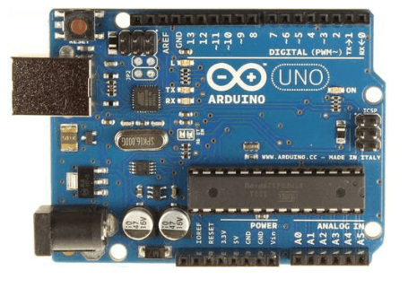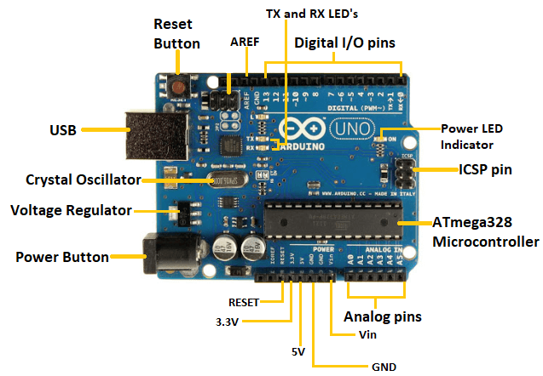

Fig: Arduino UNO board Fig: components of Arduino UNO board

Let's discuss each component in detail:

* **ATmega328 Microcontroller**- It is a single chip Microcontroller of the ATmel family. The processor code inside it is of 8-bit. It combines **Memory (SRAM, EEPROM, and Flash), Analog to Digital Converter, SPI serial ports, I/O lines, registers, timer, external and internal interrupts, and oscillator.**
* **ICSP pin**- The In-Circuit Serial Programming pin allows the user to program using the firmware of the Arduino board.
* **Power LED Indicator**- The ON status of LED shows the power is activated. When the power is OFF, the LED will not light up.
* **Digital I/O pins**- The digital pins have the value HIGH or LOW. The pins numbered from D0 to D13 are digital pins.
* **TX and RX LED's**- The successful flow of data is represented by the lighting of these LED's.
* **AREF-**The Analog Reference (AREF) pin is used to feed a reference voltage to the Arduino UNO board from the external power supply.
* **Reset button**- It is used to add a Reset button to the connection.
* **USB**- It allows the board to connect to the computer. It is essential for the programming of the Arduino UNO board.
* **Crystal Oscillator**- The Crystal oscillator has a frequency of 16MHz, which makes the Arduino UNO a powerful board.
* **Voltage Regulator**- The voltage regulator converts the input voltage to 5V.
* **GND**- Ground pins. The ground pin acts as a pin with zero voltage.
* **Vin**- It is the input voltage.
* **Analog Pins**- The pins numbered from A0 to A5 are analog pins. The function of Analog pins is to read the analog sensor used in the connection. It can also act as GPIO (General Purpose Input Output) pins.

### Technical Specifications of Arduino UNO:

* There are 20 Input/Output pins present on the Arduino UNO board. These 20 pis include 6 PWM pins, 6 analog pins, and 8 digital I/O pins.
* The PWM pins are Pulse Width Modulation capable pins.
* The crystal oscillator present in Arduino UNO comes with a frequency of 16MHz.
* It also has a Arduino integrated Wi-Fi module. Such Arduino UNO board is based on the Integrated Wi-Fi ESP8266 Module and ATmega328P microcontroller.
* The input voltage of the UNO board varies from 7V to 20V.
* Arduino UNO automatically draws power from the external power supply. It can also draw power from the USB.
  1. **BUZZER**

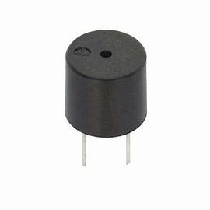

**Fig: Buzzer**

The buzzer will sense the noise when a car met with an collision for atleast 10 sec.

This kind of buzzer is made with a resonance box, multi resonator, piezoelectric plate, housing, impedance matcher, etc. Some of the buzzers are also designed with LEDs. The multi resonator of this mainly includes ICs and transistors. Once the supply is given to this resonator, it will oscillate and generates an audio signal with 1.5 to 2.kHz.

The buzzer is a sounding device that can convert audio signals into sound signals. It is usually powered by DC voltage. It is widely used in alarms, computers, printers and other electronic products as sound devices. It is mainly divided into piezoelectric buzzer and electromagnetic buzzer, represented by the letter "H" or "HA" in the circuit. According to different designs and uses, the buzzer can emit various sounds such as music, siren, buzzer, alarm, and electric bell.

* 1. **GPS-6M**

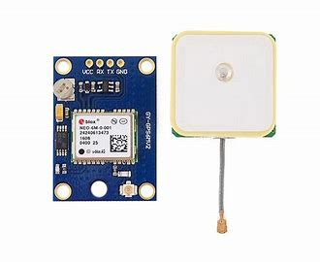

**Fig: GPS-6M**

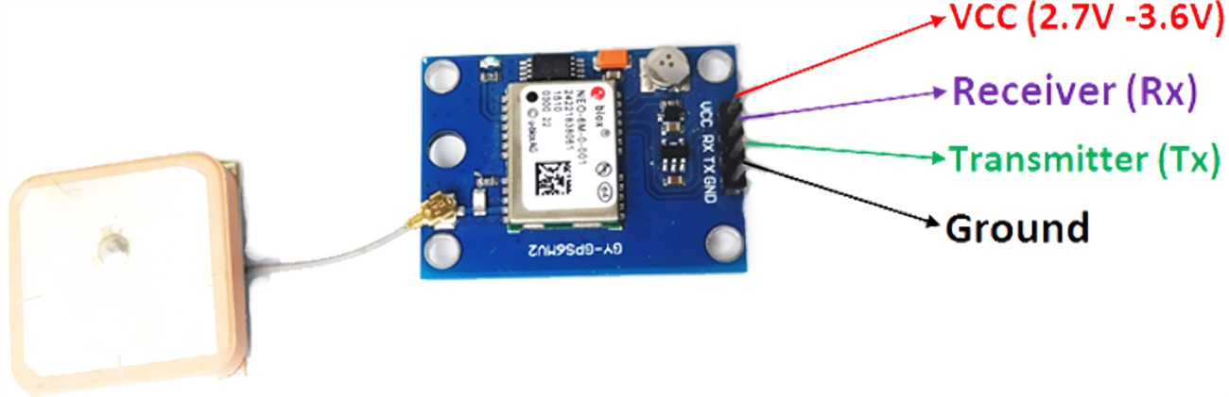

**Fig: components of GPS-6M**

GPS-6M is used to share the current accidental location to user contact list.

The heart of the module is a NEO-6M GPS chip from u-blox. It can track up to 22 satellites on 50 channels and achieves the industry’s highest level of sensitivity i.e. -161 dB tracking, while consuming only 45mA supply current. The u-blox 6 positioning engine also boasts a Time-To-First-Fix (TTFF) of under 1 second. One of the best features the chip provides is Power Save Mode(PSM). It allows a reduction in system power consumption by selectively switching parts of the receiver ON and OFF. This dramatically reduces power consumption of the module to just 11mA making it suitable for power sensitive applications like GPS wristwatch. The necessary data pins of NEO-6M GPS chip are broken out to a "0.1″ pitch headers. This includes pins required for communication with a microcontroller over UART.

This system allows you to track your vehicle anytime and anywhere. Whether you own a company with a fleet of hundreds of vehicles or you have expensive piece of equipment and you want to keep an eye on them, this tracking system can inform you of the status without you having to be actually present on the site.

* 1. **ACCELEROMETER**

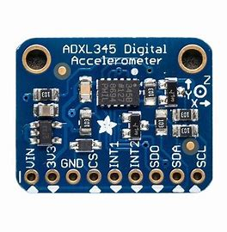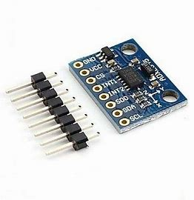

**Fig: Accelerometer**

An accelerometer is used to detect when there is change of axis in a car due to collision. This will assign GSM 800 A to send default message to the user contact list along with the current accidental location.

An accelerometer works using an electromechanical sensor that is designed to measure either static or dynamic acceleration. Static acceleration is the constant force acting on a body, like gravity or friction. These forces are predictable and uniform to a large extend. For example, the acceleration due to gravity is constant at 9.8m/s, and the gravitation force is almost the same at every point on earth.

Dynamic acceleration forces are non-uniform, and the best example is vibration or shock. A car crash is an excellent example of dynamic acceleration. Here, the acceleration change is sudden when compared to its previous state. The theory behind accelerometers is that they can detect acceleration and convert it into measurable quantities like electrical signals".

* 1. **GSM 800 A**

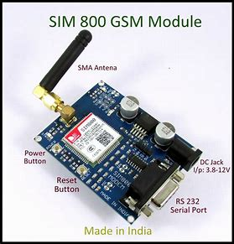

**Fig: GSM 800 A**

Whenever any accident occurs mems sensor detects and sends mechanical force to ARM, by using GPS, we will get particular location where accident occurs, then GSM sends message to authorized members which is user contact list & 108 θOne more best feature is whenever any authorized people get accidental location along with default message.

The **Global System for Mobile Communications** (**GSM**) is a standard developed by the [European Telecommunications Standards Institute](https://en.wikipedia.org/wiki/European_Telecommunications_Standards_Institute) (ETSI) to describe the protocols for second-generation ([2G](https://en.wikipedia.org/wiki/2G)) digital [cellular networks](https://en.wikipedia.org/wiki/Cellular_network) used by mobile devices such as mobile phones and tablets. It was first deployed in [Finland](https://en.wikipedia.org/wiki/Finland) in December 1991. By the mid-2010s, it became a global standard for mobile communications achieving over 90% market share, and operating in over 193 countries and territories.

The system can be mounted or fitted in your vehicle in a hidden or suitable compartment. After this installation, you can easily track your vehicle using your mobile phone by dialling the mobile number of the SIM attached to the GSM modem. You will automatically get the location of the vehicle in the form of an SMS (short message) on your mobile phone.

## 5.6 EMBEDDED C

Embedded C is a set of language extensions for the C programming language by the C Standards Committee to address commonality issues that exist between C extensions for different embedded systems. Historically, embedded C programming requires nonstandard extensions to the C language in order to support exotic features such as fixed-point arithmetic, multiple distinct memory banks, and basic I/O operations.

#### Embedded Programming

Embedded refers to the combination of hardware and software. Embedded systems programming is the programming of an embedded system in some device using the permitted programming interfaces provided by that system. Embedded Java is an example of a development environment for programming embedded systems that will execute Java programs.

Arduino is a very minute part of embedded systems, in fact we can call it as an application product of embedded system. Arduino is just any other microcontroller board, with a specifically designed API and software which makes programming it very easy. Arduino is just a drop of water in Embedded System O

1. **CODING**

#include <Wire.h>

#include <SoftwareSerial.h>

#include <TinyGPS++.h>

#include "MPU6050_6Axis_MotionApps20.h"

SoftwareSerial mySerial(10, 11);

SoftwareSerial mySerialGps(9, 10);

static const int RXPin = 4, TXPin = 3;

static const uint32_t GPSBaud = 9600;

// The TinyGPS++ object

TinyGPSPlus gps;

// The serial connection to the GPS device

SoftwareSerial ss(RXPin, TXPin);

#define default_co_ordinates "13.0837722,77.4820204"

#define buzzer 6

#define button 11

#define command 8

String data, url = "";

int count = 1;

static boolean flag = true;

MPU6050 mpu;

// MPU6050 Slave Device Address

const uint8_t MPU6050SlaveAddress = 0x68;

// Select SDA and SCL pins for I2C communication

const uint8_t scl = A5;

const uint8_t sda = A4;

// sensitivity scale factor respective to full scale setting provided in datasheet

const uint16_t AccelScaleFactor = 16384;

const uint16_t GyroScaleFactor = 131;

// MPU6050 few configuration register addresses

const uint8_t MPU6050_REGISTER_SMPLRT_DIV = 0x19;

const uint8_t MPU6050_REGISTER_USER_CTRL = 0x6A;

const uint8_t MPU6050_REGISTER_PWR_MGMT_1 = 0x6B;

const uint8_t MPU6050_REGISTER_PWR_MGMT_2 = 0x6C;

const uint8_t MPU6050_REGISTER_CONFIG = 0x1A;

const uint8_t MPU6050_REGISTER_GYRO_CONFIG = 0x1B;

const uint8_t MPU6050_REGISTER_ACCEL_CONFIG = 0x1C;

const uint8_t MPU6050_REGISTER_FIFO_EN = 0x23;

const uint8_t MPU6050_REGISTER_INT_ENABLE = 0x38;

const uint8_t MPU6050_REGISTER_ACCEL_XOUT_H = 0x3B;

const uint8_t MPU6050_REGISTER_SIGNAL_PATH_RESET = 0x68;

int16_t AccelX, AccelY, AccelZ, Temperature, GyroX, GyroY, GyroZ;

void setup() {

Serial.begin(9600);

///////////////////////////GPS SETUP//////////////////////////////////////////

mySerialGps.begin(9600);

Serial.println("Hi initilizing the system.");

delay(100);

ss.begin(GPSBaud);

Serial.println("In recieving mode.");

mySerialGps.println("AT+CNMI=2,2,0,0,0\r"); // AT Command to receive a live SMS

delay(1000);

////////////////////////////////////////////////////////////////////////////

//////////////////////////MPU 6050 SETUP/////////////////////////////////////

Wire.begin();

// sgps.begin(9600);

Serial.println(F("Initializing I2C devices..."));

mpu.initialize();

// verify connection

Serial.println(F("Testing device connections..."));

Serial.println(mpu.testConnection() ? F("MPU6050 connection successful") : F("MPU6050 connection failed"));

// load and configure the DMP

Serial.println(F("Initializing DMP..."));

mpu.dmpInitialize();

// supply your own gyro offsets here, scaled for min sensitivity

mpu.setXGyroOffset(220);

mpu.setYGyroOffset(76);

mpu.setZGyroOffset(-85);

mpu.setZAccelOffset(1788);

pinMode(command, OUTPUT);

pinMode(buzzer, OUTPUT);

pinMode(button, INPUT);

///////////////////////////////////////////////////////////////////////////////

}

void loop() {

if (flag) {

double Ax, Ay, Az, T, Gx, Gy, Gz;

Read_RawValue(MPU6050SlaveAddress, MPU6050_REGISTER_ACCEL_XOUT_H);

//divide each with their sensitivity scale factor

Ax = (double) AccelX / AccelScaleFactor;

Ay = (double) AccelY / AccelScaleFactor;

Az = (double) AccelZ / AccelScaleFactor;

T = (double) Temperature / 340 + 36.53; //temperature formula

Gx = (double) GyroX / GyroScaleFactor;

Gy = (double) GyroY / GyroScaleFactor;

Gz = (double) GyroZ / GyroScaleFactor;

Serial.print("Ax: ");

Serial.print(Ax);

Serial.print(" Ay: ");

Serial.print(Ay);

Serial.print(" Az: ");

Serial.print(Az);

Serial.print(" T: ");

Serial.print(T);

Serial.print(" Gx: ");

Serial.print(Gx);

Serial.print(" Gy: ");

Serial.print(Gy);

Serial.print(" Gz: ");

Serial.println(Gz);

if (Gy >= 05.0 || Gy <= -05.0 || Gx >= 05.0 || Gx <= -05) {

Serial.println("ANGLE CHANGE IN Z DIRECTION IS SUDDEN!!!!");

//////////////

sendSms();

////////////////

int x = millis();

int time = millis() - x;

while (time <= 10000 && digitalRead(button) == LOW) {

time = millis() - x;

digitalWrite(buzzer, HIGH);

delay(1000);

}

digitalWrite(buzzer, LOW);

if (time >= 1000) {

flag = false;

digitalWrite(command, HIGH);

}

}

}

if (digitalRead(button) == HIGH) {

flag = true;

digitalWrite(command, LOW);

}

while (ss.available() > 0)

if (gps.encode(ss.read()))

displayInfo();

if (millis() > 5000 && gps.charsProcessed() < 10) {

//Serial.println(F("No GPS detected: check wiring."));

//while (true);

displayInfo();

}

delay(100);

}

void I2C_Write(uint8_t deviceAddress, uint8_t regAddress, uint8_t data) {

Wire.beginTransmission(deviceAddress);

Wire.write(regAddress);

Wire.write(data);

Wire.endTransmission();

}

// read all 14 register

void Read_RawValue(uint8_t deviceAddress, uint8_t regAddress) {

Wire.beginTransmission(deviceAddress);

Wire.write(regAddress);

Wire.endTransmission();

Wire.requestFrom(deviceAddress, (uint8_t) 14);

AccelX = (((int16_t) Wire.read() << 8) | Wire.read());

AccelY = (((int16_t) Wire.read() << 8) | Wire.read());

AccelZ = (((int16_t) Wire.read() << 8) | Wire.read());

Temperature = (((int16_t) Wire.read() << 8) | Wire.read());

GyroX = (((int16_t) Wire.read() << 8) | Wire.read());

GyroY = (((int16_t) Wire.read() << 8) | Wire.read());

GyroZ = (((int16_t) Wire.read() << 8) | Wire.read());

}

//configure MPU6050

void MPU6050_Init() {

delay(1500);

I2C_Write(MPU6050SlaveAddress, MPU6050_REGISTER_SMPLRT_DIV, 0x07);

I2C_Write(MPU6050SlaveAddress, MPU6050_REGISTER_PWR_MGMT_1, 0x01);

I2C_Write(MPU6050SlaveAddress, MPU6050_REGISTER_PWR_MGMT_2, 0x00);

I2C_Write(MPU6050SlaveAddress, MPU6050_REGISTER_CONFIG, 0x00);

I2C_Write(MPU6050SlaveAddress, MPU6050_REGISTER_GYRO_CONFIG, 0x00); //set +/-250 degree/second full scale

I2C_Write(MPU6050SlaveAddress, MPU6050_REGISTER_ACCEL_CONFIG, 0x00); // set +/- 2g full scale

I2C_Write(MPU6050SlaveAddress, MPU6050_REGISTER_FIFO_EN, 0x00);

I2C_Write(MPU6050SlaveAddress, MPU6050_REGISTER_INT_ENABLE, 0x01);

I2C_Write(MPU6050SlaveAddress, MPU6050_REGISTER_SIGNAL_PATH_RESET, 0x00);

I2C_Write(MPU6050SlaveAddress, MPU6050_REGISTER_USER_CTRL, 0x00);

}

void sendSms() {

mySerialGps.println("AT+CMGF=1\r"); //Sets the GSM Module in Text Mode

delay(1000); // Delay of 1 second

mySerialGps.println("AT+CMGS=\"+919986624722\"\r"); // Replace x with mobile number

delay(1000);

String mesage = "ATTENTION!! Your device has met with a serious accident the vehicle location is : ";

mesage.concat(url);

mySerialGps.println(mesage); // The SMS text you want to send

delay(100);

mySerialGps.println((char) 26); // ASCII code of CTRL+Z for saying the end of sms to the module

delay(1000);

Serial.println("In recieving mode.");

mySerialGps.println("AT+CNMI=2,2,0,0,0\r");

}

void displayInfo() {

//Serial.print(F("Location: "));

if (gps.location.isValid()) {

url = "http://www.google.com/maps/place/";

url.concat(String(gps.location.lat(), 6));

url.concat(",");

url.concat(String(gps.location.lng(), 6));

Serial.println(url);

delay(1000);

} else {

Serial.print(F("INVALID"));

url = "http://www.google.com/maps/place/";

url.concat(default_co_ordinates);

delay(1000);

//Serial.println(url);

}

if (mySerial.available() > 0) {

Serial.print(mySerial.read());

}

Serial.println();

count++;

//delay(1000);

}

1. **TESTING**

Testing is the process of running a system with the intention of finding errors. Testing aims at detecting error -prone areas. This helps in the in the prevention of errors in a system. Testing also adds value to the product by confirming to the user requirements. The main purpose of testing is to detect error and error -prone areas in a system testing must be through and well planned. A partially tested system is as bad as an untested system and the price of an untested and under tested system is high. System testing involves unit testing, integration testing, white-box testing, black-box testing. Strategies for integration software components into a product include the bottom-up strategy, top-down strategy. Careful planning and scheduling are required to ensure that modules that will be available for integration into evolving software product when needed a serious of testing are performed for the proposed system before the system is ready for user acceptance testing.

**7.1 Test objectives**

* Testing is a process of executing a program with the intent of finding an error.
* A good case is one that has a high probability of finding an undiscovered error.
* A successful test is one that uncovers a yet undiscovered error. If testing is conducted successfully (according to the objectives) it will uncover errors in the software. Testing can’t show the absences of defects are present. It can only show that software defects are present.

**Testing Principles**

Before applying methods to design effective test cases, a software engineer must understand the basic principle that guides software testing. All the tests should be traceable to customer requirements.

**Testing Design**

Any engineering product can be tested in one of two way, they are white box testing and black box testing.

**Testing Strategies**

A software testing strategy provides a road map for the software developer. Testing is a set of activities that can be planned in advance and conducted systematically. For this reason a template foe software testing a set of steps into which we can place specific test case design methods should be defined for software engineering process.

**Any software testing strategy should have the following characteristics:**

1. Testing begins at the module level and works outward toward the integration of the entire computer based system.
2. Different testing techniques are appropriate at different points in time.
3. The developer of the software and an independent test group conducts testing.
4. Testing and debugging are different activities but debugging must be accommodated in any testing strategy.

**7.2 Levels of Testing**

Testing can be done in different levels of SDLC. They are:

**Unit Testing**

Instead of testing the system as a whole, Unit testing focuses on the modules that make up the system. Each module is taken up individually and tested for correctness in coding and logic**.**

The advantages of unit testing are:

* Size of the module is quite small and that errors can easily are located.
* Confusing interactions of multiple errors in wide different parts of the software is   
  eliminated.
* Modules level testing can be exhaustive.

**Integration Testing**

It tests for the errors resulting from integration of modules. One specification of integration testing is whether parameters match on both sides of type, permissible ranges and meaning. Integration testing is functional black box test method. It includes testing each module as an impenetrable mechanism for information. The only concern du*ri*ng integration testing is that the modules work together properly.

**White Box Testing (Code Testing)**

The code-testing strategy examines the logic of the program. To follow this testing method, the analyst develops test cases that result in executing every instruction in the program or module so that every path through the program is tested. A path is a specific combination of conditions that is handled by the program. Code testing does not check the range of data that the program will accept.

* Exercises all logical decisions on their true or false sides**.**
* Executes all loops at their boundaries and within these operational bounds.

**Black box testing specification**

To perform specification testing, the analyst examines the specification, starting from what the program should do and how it should perform under various conditions. Then test cases are developed for each condition or combinations of conditions and submitted for processing. By examining the results, the analyst can determine whether the programs perform according to its specified requirements. This testing strategy sounds exhaustive. If every statement in the program is checked for its validity, there doesn't seem to be much scope for errors.

**Functional testing**

In this type of testing, the software is tested for the functional requirements. The tests are written in order to check if the application behaves as expected. Although functional testing is often done toward the end of the development cycle, it can and should, be started much earlier. Individual components and processes can be tested early on, even before it's possible to do functional testing on the entire system. Functional testing covers how well the system executes the functions it is supposed to execute including user commands, data manipulation, searches and business processes, user screens, and integrations. Functional testing covers the obvious surface type of functions, as well as the back-end operations (such as security and how upgrades affect the system).

**Performance Testing**

In software engineering, performance testing is testing that is performed, from one perspective, to determine how fast some aspect of a system performs under a particular workload. It can also serve to validate and verify other quality attributes of the system, such as scalability, reliability and resource usage. Performance testing is a subset of Performance engineering, an emerging computer science practice which strives to build performance into the design and architecture of a system, prior to the onset of actual coding effort.

Performance testing can serve different purposes. It can demonstrate that the system meets performance criteria. It compares two systems to find which performs better. Or it can measure what parts of the system or workload cause the system to perform badly. In the diagnostic case, software engineers use tools such as profilers to measure what parts of a device or software contribute most to the poor performance or to establish throughput levels (and thresholds) for maintained acceptable response time. It is critical to the cost performance a new system; the performance test efforts begin at the inception of the development project and extend through to deployment. The later a performance defect is detected, the higher the cost of remediation. This is true in the case of functional testing, but even more so with performance testing, due to the end-to-end nature of its scope.

In performance testing, it is often crucial (and often difficult to arrange) for the test conditions to be similar to the expected actual use. This is, however, not entirely possible in actual practice. The reason is that production systems have a random nature of the workload and while the test workloads do their best to mimic what may happen in the production environment, it is impossible to exactly replicate this workload variability - except in the simplest system.

**TEST CASES**

|  |  |
| --- | --- |
| Test Case ID | Unit Test Case 1 |
| Description | Buzzer sensor |
| Input | Accelerometer will detect the collision is sensed by the buzzer |
| Expected Output | Buzzer has to make noise |
| Actual Result | Got the expected output |
| Passed(?) | Yes |

**Fig: Unit Test Case 1**

|  |  |
| --- | --- |
| Test Case ID | Unit Test Case 2 |
| Description | Sim Network |
| Input | Accelerometer will detect the collision and allows the GSM to use sim network |
| Expected Output | When a car met with a collision, sim network has to send message to user contact list. |
| Actual Result | Got the expected output |
| Passed(?) | Yes |

**Fig: Unit Test Case 2**

|  |  |
| --- | --- |
| Test Case ID | Unit Test Case 3 |
| Description | GPS 6 M |
| Input | Accelerometer will detect the collision and allows the GPS to track live location. |
| Expected Output | When a car met with a collision, GPS has to send accidental location to user contact list. |
| Actual Result | Got the expected output |
| Passed(?) | Yes |

**Fig: Unit Test Case 3**

1. **RESULT**
   1. **DEFAULT MESSAGE**

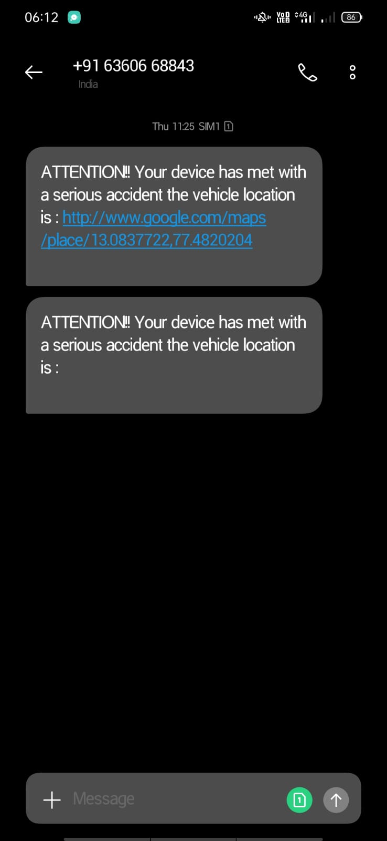

**Fig: default message sent to user contact list**

When a car met with a collision, the accelerometer detects the collision and allows GSM 800A to send default messages to user contact list.

* 1. **GPS LOCATION**

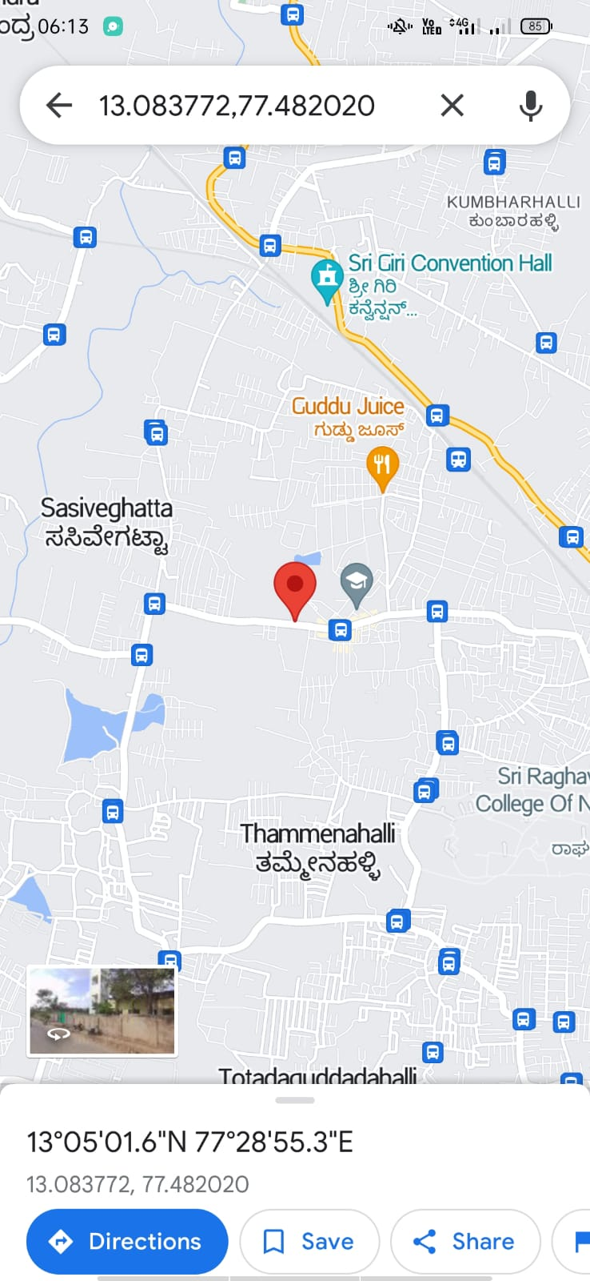

**Fig: GPS accidental location sent to user contact list**

When a car met with a collision, the accelerometer detects the collision and allows GSM 800A to send default messages along with accidental location to user contact list.

1. **CONCLUSION**

The proposed programmed accident detection system can be a rescuer of life for the people

who met with accidents. The proposed system is exceptionally easy to understand and even a non-specialized Person can use it without any problem. The system consists of equipment and programming segments. The equipment unit includes accident detection sensors that are constrained by an Arduino board and is fitted in the vehicle. Then again, the programming part is an Android application introduced in drivers Smartphones which is used to get the point by point map. In general, the benefits of this system are low cost, secure and simple to use. The system introduced in this work reduces the casualties due to accidents.

Accident detection operation is not an easy task to handle;

it can be an extremely complicated process when it comes to

real time applications, which is the main reason why it is not

implemented yet on a large scale. The proposed system will

help to improve the present scenarios.

• Although in-vehicle accident detection system

provides emergency responders with essential information as

fast as possible but unavailability of this system are restricted

by their non-portability and costs, whereas Smartphone

provides a promising platform with same sensors at cheap

Accident detection operation is not an easy task to handle;

it can be an extremely complicated process when it comes to

real time applications, which is the main reason why it is not

implemented yet on a large scale. The proposed system will

help to improve the present scenarios.

• Although in-vehicle accident detection system

provides emergency responders with essential information as

fast as possible but unavailability of this system are restricted

by their non-portability and costs, whereas Smartphone

provides a promising platform with same sensors at cheap

Accident detection operation is not an easy task to handle; it can be an extremely complicated process when it comes to real time applications, which is the main reason why it is not implemented yet on a large scale. The proposed system will help to improve the present scenarios.

• Although in-vehicle accident detection system provides emergency responders with essential information as fast as possible but unavailability of this system are restricted by their non-portability and costs, whereas Smartphone provides a promising platform with same sensors at cheap price and portability benefits. Smartphone can surpass the functionality of conventional in vehicle accident detection system.

**10. FUTURE ENHANCEMENT**

This project can be integrated to the virtual systems of the vehicle.

• Various Smartphone based accident detection systems are exposed to false positive readings. In the proposed system various sensors and features are introduced to incr ease the accuracy of the system. It is also have additional key feature of resetting the alarm which is not present in the referenced system. Our system will impressively decrease the redundancy found in other accident detection systems.

• ADAS Smartphone interface will have activation/deactivation button which will allow the user to start or stop medical response in a time window of 30 seconds, after which the medical assistance will be called by default. The user will also have option to call back the medical service even when the alarm is not initiated.

* ADAS software will allow the uninjured client and the observers to take images, videos of the accident and send them to emergency responders to report the accident.
* ADAS software will quickly notify the friends or family of the client. The notification will be sent to pre-registered emergency contacts and it will provide the exact position of the accident site.
* Implementation of emergency contacts of police station and hospitals.
* Implementation of latest GPS 7M.

**11. REFERENCES**

1) "A Brief History of GPS Vehicle Tracking", Trackyourtruck.com, 2017. [Online]. Available: http://www.trackyourtruck.com/blog/briefhistory-gps vehicle-tracking.

2)"Vehicle_tracking_system",En.wikipedia.org,2017. [Online].Available:https://en.wikipedia.org/wiki/V ehicle tracking system.

3) Chen Peijiang, Jiang Xuehua, “Design and Implementation of Remote monitoring system based on GSM,” vol.42, pp.167 175. 2008.

4) Albert Alexe, R.Ezhilarasie, “Cloud Computing Based Vehicle Tracking Information Systems”, ISSN: 2229 – 4333.

5) Edmond Chin-Ping Chang, 1992. A Neural Network Approach to Freeway Incident Detection. IEEE, pp. 641-647.

6) Edmond Chin-Ping Chang, Kunhuang Huarng, 1993. Fuzzy Set Applications for Freeway Incident Detection. IEEE, pp. 439-443.

7) C. Koc¸kan, “Communication between vehicles,” PhD thesis, Istanbul Technical University, 2008.

8) H. Lee, “Algorithms to improve the quality of traffic freeway detector data,” PhD thesis, Ohio State University, 2012.

9) J. Lu, S. Chen, W. Wang, and B. Ran, “Automatic traffic incident detection based on foil,” Expert Systems with Applications, vol. 39, no. 7, pp. 6547– 6556, 2012.

10) J. Lu, S. Chen, W. Wang, and H. van Zuylen, “A hybrid model of partial least squares and neural network for traffic incident detection,” Expert Systems with Applications, vol. 39, no. 5,

**REFERENCES:**

* [http://sites.ndtv.com/roadsafety/important-feature-to-you-in-your- car/](http://sites.ndtv.com/roadsafety/important-feature-to-you-in-your-%20car/)
* <http://www1.cse.wustl.edu/~schmidt/PDF/wreckwatch.pdf>
* <http://mobilware.org/2010/presentations/Car%20Accidents.pdf>
* <http://www.losangelespersonalinjurylawyers.co/top-10-causes-of-car-accidents/>
* <http://www.tutorialpoint.com/android>